Lecture 3

.INNOVATIVE TOOLS

(A)MULTIMEDIA LEARNING PROCESS
I hear and I forget.
I see and I believe.
I do and I understand. - Confucius
Multimedia, is the combination of various digital media types such as text, images, audio and video, into an integrated multi-sensory interactive application or presentation to convey information to an audience. Traditional educational approaches have resulted in a mismatch between what is taught to the students and what the industry needs. As such, many institutions are moving towards problembased learning as a solution to producing graduates who are creative; think critically and analytically, to solve problems. In this paper, we focus on using multimedia technology as an innovative teaching and learning strategy in a problem-based learning environment by giving the students a multimedia project to train them in this skill set.
Currently, many institutions are moving towards problem-based learning as a solution to producing graduates who are creative and can think critically, analytically, and solve problems. Since knowledge is no longer an end but a means to creating better problem solvers and encourage lifelong learning. Problem-based learning is becoming increasingly popular in educational institutions as a tool to address the inadequacies of traditional teaching. Since these traditional approaches do not encourage students to question what they have learnt or to associate with previously acquired knowledge (Teo & Wong, 2000), problem-based learning is seen as an innovative measure to encourage students to learn how to learn via real-life problems (Boud & Feletti, 1999).
The teacher uses multimedia to modify the contents of the material. It will help the teacher to represent in a more meaningful way, using different media elements. These media elements can be converted into digital form, modified and customized for the final presentation. By incorporating digital media elements into the project, the students are able to learn better since they use multiple sensory modalities, which would make them more motivated to pay more attention to the information presented and retain the information better.

Chart 1 - MULTMEDIA ELEMENTS
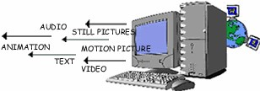

Creating multimedia projects is both challenging and exciting. Fortunately, there are many multimedia technologies that are available for developers to create these innovative and interactive multimedia applications (Vaughan, 1998). These techologies include Adobe Photoshop and Premier to create edit graphics and video files respectively, SoundForge and 3D Studio Max to create and/or edit sound and animation files, respectively. They can also use an authoring tool such as Macromedia Director or Authorware to integrate and synchronise all these media elements into one final application, add interactive features, and package the application into a distributable format for the end-user.
Another advantage of creating multimedia projects in the classroom setting is that when students create multimedia projects, they tend to do this in a group environment. By working in a group, the students would have to learn to work cooperatively and collaboratively, using their group skills and a variety of activities to accomplish the project’s overall objectives.
TRADITIONAL AND MULTIMEDIA LEARNING THE DIFFERNCE

Chart 2 - TRADITIONAL METHOD – A ONE WAY FLOW

STUDENTS

TEACHER

Chart 3 - MULTIMEDIA LEARNING – AN INTERACTIVE LEARNING PROCESS
STUDENT 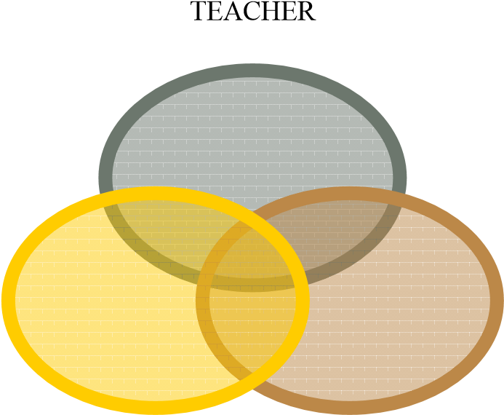 MULTIMEDIA

VARIOUS MULTIMEDIA TOOLS
Tools | METHODS | EXAMPLES | METAPHORS
Mspowerpoint, Astound  Graphics and Flash Slide  Show Software | Easy to prepare and it can be prepared with many of the popular multimedia elements like graphs, sound and video. | 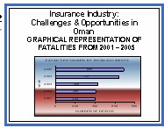 | SLIDE BASED
Macromedia, Flash Authorware, BPP I  Learn and I Pass | Presentation is created using icons to represent different media elements and placed in a flowline. |  | ICON BASED
Windows Movie Maker, Winampp, Macromedia  Director | Presentation is  created using moviemaking concepts of casts, sounds,  pictures and scores |  | MOVIE  BASED
Adobe Acrobat Reader | Easy to prepare and with word documents if u have Acrobat Reader 5 with many popular multimedia elements like graphs sound and charts | 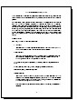 | BOOK BASED

(B)OTHER INNOVATIE TOOLS SUGGESTED
The researchers suggest some of the methods can very well be applied by the modern teachers. As the researchers feel that basically the core objective of teaching should never be deviated by the use of an innovative method. The following methods which are suggested are an extension to the traditional methods of teaching.

(1) MIND MAP
Mind maps were developed in the late 60s by Tony Buzan as a way of helping students make notes that used only key words and images, but mind map can be used by teachers to explain concepts in an innovative way. They are much quicker to make and much easier to remember and review because of their visual quality. The nonlinear nature of mind maps makes it easy to link and cross-reference different elements of the map.
Mind Maps are also very quick to review, as it is easy to refresh information in your mind just by glancing once. Mind Maps can also be effective mnemonics and remembering their shape and structure can provide the cues necessary to remember the information within it. They engage much more of the brain in the process of assimilating and connecting facts than conventional notes.
The key notion behind mind mapping is that we learn and remember more effectively by using the full range of visual and sensory tools at our disposal. Pictures, music, color, even touch and smell play a part in our learning armory will help to recollect information for long time. The key is to build up mind maps that make the most of these things building on our own creativity, thinking and cross linking between ideas that exist in our own minds.
As the recent research point that any particular information explained with the help of graph charts make a high impact in the minds of the people and keeping this as the core aspect the teachers may try to picturize the concepts and show the same to the students

Chart 4 - AN EXAMPLE OF MIND MAP FOR SCALAR QUANTITIES
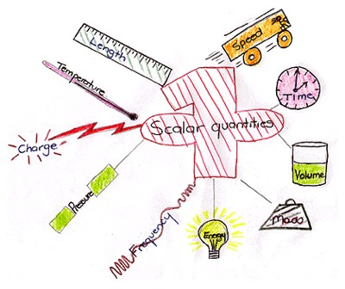

This would bring very high impact on the minds of the students about a concept
- Creates clear understanding  PowerPoint can be used widely.
- Innovative thinking improves

(2 ) TEACHING WITH SENSE OF HUMOUR – “HUMOUR AN EFFECTIVE MEDIUM OF TEACHING”
Everyone loves a teacher with an infectious sense of humor. Looking at the lighter side of life not only fosters cordial relations between professors and students, but also provides welcome relief while trying to follow a difficult lecture on a complicated subject. When there is a willingness to change, there is hope for progress in any field. Teaching is a challenge. Learning is a challenge. Combining both effectively is a challenge. Being humorous is a challenge. However, laughing is easy. We are convinced both by experience and research that using humour in teaching is a very effective tool for both the teacher and student.
Humor strengthens the relationship between student and teacher, reduces stress, makes a course more interesting and if relevant to the subject, may even enhance recall of the material. Humor has the ability to relax people, reduce tension, and thereby create an atmosphere conducive for learning and communication. Numerous studies in the field of advertising have noted that humor is the most effective tool for enhancing recall of advertisements.
It is easy to create a humor in the classroom by reading books of jokes and to listen to professional comics. The students should be encouraged to take notes, especially to learn about the professionals’ use of such techniques as exaggeration, pauses, and timing. Observe reality and exaggerate it - much humor lies in observations about real life and truthful situations. In conclusion, humor not only plays an important role in the healing process but is also very important in education.

(3) Z TO A APPROACH
This approach attempts to explain the application part of a particular concept first. The teacher should explain the application of a particular concept first and explain the effects of such applications. For example in management subject - motivation is explained in a manner that the organization get extensive benefits out of using some techniques like promotions and awards. So here the use of promotion is explained first and later students would get interest in knowing what are promotions and awards. The teacher starts explaining what is promotion and explains what motivation theory in management is.Another example we can try is that in accounting the Income statement and Balance Sheet can be explained first and later drawing their attention to double entry system of book keeping.
Strengths
- Makes a particular concept clear
- Students develop interest to know exactly the concept.
- Creates long lasting memory/correlation of a concept.
Weaknesses
  - Take quite long time for a teacher to introduce a concept
  - Initial difficulty in understanding a particular concept will be encountered.

Chart 5 - LEANING TOWER OF PISA EXPERIMENT – EXAMPLE TO Z – A
APPROACH
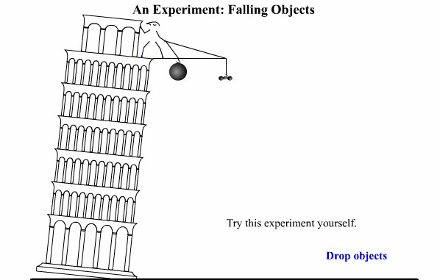

Source: vision learning
Z – A approach is explained in the following two charts. In the first chart a man drops cannonball and lead weight from the top of the building. Hypothesis for this experiment is both the object will fall at the same rate
In the second chart the cannon ball and lead weight have reached the ground.
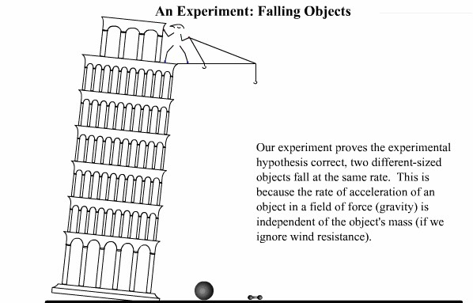

Source: vision learning
Concept Simulation - reenacts Galileo's experiment of two different objects falling at the same rate.

The above chart explains the application of that Gallileo’s theorm. Here the teacher explains how two objects reach the ground if they are put from a particular distance from ground level. Traditional way of teaching method will be explaining the theorem first and followed by its application. But this Z-A approach goes opposite in a manner that the proof or application is explained first and later the theory. Then it is explained that this the concept developed by Galileo. The above example of tower depicts a (possibly mythical) experiment in which Galileo dropped two objects from the leaning tower of pisa to demonstrate their comparable rate of descent.

(4) MNEMMONICS WORDS- WORDS –WORDS APPROACH
Here the teacher is not supposed to talk on a particular concept for a quite long time. But to make it clear to the students he can just go on saying mnemonics or its associated meaning in words. Here he goes on saying only words instead of sentence, and once they come to a basic understanding of the meaning of a particular concept then the teacher will explain in sentences. For example in teaching language courses this technique can be used as an effective medium by the teacher to develop word power.
- Dictionary must be used widely
- Word power increases
- Teacher also gets to know many words pertaining to a particular concept.

(5) ROLE PLAYING AND SCENARIO ANALYSIS BASED TEACHING
Role playing and scenario analysis is mostly used in organizations that try to analyze a problem pertaining to the organization, and this is also used in management institutions. But the similar kind of practice can be tried in other specialization too like science and engineering. Science and engineering courses have practical but in support of those practical if students are given a scenario and other options to solve a particular issue, then the students are exposed to decision making in a given environment.
For example, in teaching accounting the role of accountant can be explained by role playing technique. Invoice and bills can be given to students and asked them to assume the role of accountant. Here the real entries pertaining to transactions are made by the student and this is more practical approach to teaching where theory is supplemented by proper practical knowledge. Similar kind of technique can be applied in management, engineering and science courses.

